Refer the “Migrate Data” section of DMS service in the AWS console.

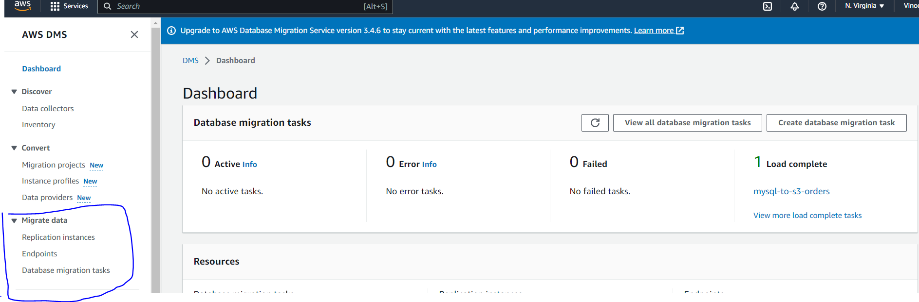

1. Create replication instance with single AZ for dev / test workloads and multi AZ for production loads.
2. Create a source endpoint to RDS MySQL database. Provide access information either through Secrets Manager or by manually entering the connectivity details.
3. Create a target endpoint to S3 bucket (my-cdc-project-bucket). Create a IAM role my-dms-role-to-access-s3 for AWS service DMS with full access to S3.
4. Create a DMS task making use of the replication instance and the endpoints created above. We choose the Migration Type as “Migrate existing data and replicate ongoing changes”. Under Mapping Rules - Selection Rules - Choose schema name is like '%dev' and Source table name is like '%Persons' to ensure only specific table is being moved.

Note that for the DMS task to complete successfully, “Enable automatic backup” must be enabled on the RDS database. Else Replication Task will fail with an error related to “binary logging configuration”

Also, I got an error related to binlog_format. For this, I created a new parameter group and changed below params. Then modified the RDS database to point to this new parameter group (instead of the default parameter group) and rebooted the database.

Set the binlog_row_image parameter to "Full" (not sure if this change is needed)

Set the binlog_checksum parameter to "NONE"(not sure if this change is needed)

Set the binlog_format parameter to "ROW" (this is definitely needed)

1. Enable pre-migration assessment. Provide details of the S3 bucket/folder where the results of the pre-migration assessment need to be stored. Provide a IAM role that has required access to the S3 bucket/folder.
2. Once the pre-migration assessment has completed successfully, resume/restart the DMS task to actually move the orders data from MySQL to S3.
3. Once the DMS task completes, verify in S3 if the initial data in MySQL has been moved to S3.
4. Implement the changes specified in 2. RDS Source Data – Changes.txt. See if another file with the information related to changes has been moved to S3.